Task 3: Literacy Strategies

Objective: To observe literacy strategies in action over 4 weeks.

Procedure
- This task is intended to be implemented over the four weeks.
- For this task student should:
- record examples of practices and/or strategies that they observe- e.g phonics, guided reading, Sustained Silent Reading, graded readers, literate-rich, print-rich environment,
- take photos and/or video recordings (if the school and the MST give permission)
- ask questions about and reflect on best practice observed

Before the Observation
Pre TP classes
- Discuss/review any relevant content from Learning to Read and Write, Section 2 “Readers & Writers in the Making” pp27-99
- Neuman, S., Copple, C. and Bredcamp, S. (2000). Learning to Read and Write. Washington: National Association for the Education of Young Children.
- (Neuman, Copple & Bredcamp, 2000, 56)

In the school

- Explain the task to your MST so she can try to highlight and include some of the strategies/aspects you may need to consider
- Decide what time(s) each day you will conduct this observation.
- See if you can find out what the teacher plans to do each day by studying his/her plans, and/or talking with them.

After the Observation - Reflection

Choose 3 best practices you observed during your time in school. Reflect on these and consider why you could implement these in a UAE primary classroom in the future. Explain how these practices will affect student learning and reading levels in a primary class.

- phonics: When I observed Ms. Talia's class before she starts the lesson she gave them a phonics quick activity which was fun and impressive to me because I never saw my MST gives them phonics practice because they are grade five.

As ms.Talia believes because they are second language learners they must have phonics practice once every one to two weeks as a reminder and I completely agree with her.

- Guided reading: I personally did try using guided reading three times during this semesters TP and by looking at the lessons I taught and what my MST taught guided reading is the most effective type for grade five students because when students know and have some supervising them and asking the questions they tend to be fully focused in their reading

- print-rich environment: private schools tend to have lots of print surrounding the class and they display students work and talk about the print in class when there is a subject taught and something related to it is in the class which is very helpful in getting students engaged and as a strong reminder they can always go around the class and look for information.

LITERACY STRATEGIES

Observe your MST’s classroom and general practices you see around the school. Discuss the areas below in context of what you observe in school and support with a photo and a reference to reading when possible.

Describe the classroom environment.

The class room Organization wise I very massy however the flow of the class is very good and most of the time students are engaged.

Consider how the class is a print rich environment. What print can you see around the room? (labels, captions, flashcards, headings, rules, instructions, timetable, flash cards, etc) For each one you mention insert pictures and state the purpose of each one.

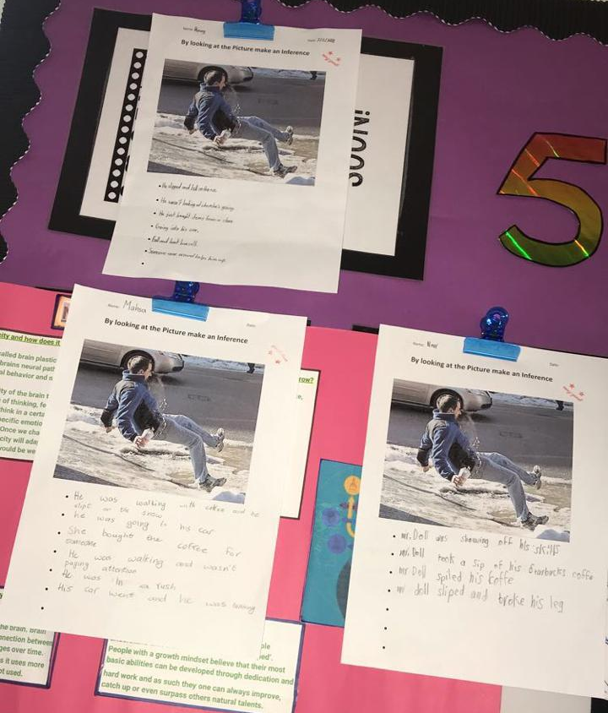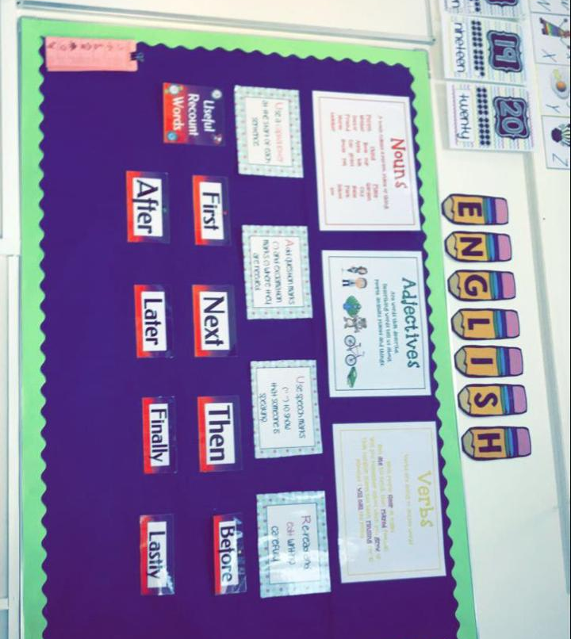
English basics having it as a reminder and its helpful for the practice classes
Displaying Students activity worksheets on the back board as a praise and for students to go back to it and learn from it

Is there a variety of books and genres in the class? Mention some. How are they displayed?

There is a reading corner and there is three boxes with different reading level books in them
During their break or during reading class they can go and grab a book and read alone or with a reading buddy

Describe the reading area in your classroom.

In the back of the class there is a soft traditional Arabic seating with levelled books

Does the teacher read to the children? How often? How does she motivate them to read?

When students come back from sports or a break and they are hyped up my MST reads a calming book and asks students to close their eyes and listen.

Describe the reading approaches have you observed? Where do the children sit? How does the teacher encourage participation?

Read aloud | Shared reading | Guided reading | Independent reading
Whenever there is a long text my MST encourages the students to read.  He picks a student and ask him to read and the next student so on. | When I attended Ahlam's MST class I saw her teach a shared reading lesson  It was about the good and bad habits and what a good kid should do the story had a moral and students wore engaged the teacher kept asking the questions and in the end they had an activity | My MST helps student who need scaffolding and lets the more able students help the struggling students.  He asks students questions after they finish each paragraph. | Whenever students are introduced to a new topic they are encouraged to use their devices and research about the topic and read to have a general knowledge about it

Consider how the teacher reminds children of any concepts of print when reading? (left-to-right, top to bottom, punctuation, author, illustrator, etc)

My MST never needed to remind them of the basics of print because they are grade five most of them are mastered however he does remind them just in case they forgot. When tells them about what they are going to do (instructions of the activity).

How does the teacher teach phonics and word attack skills to children? Describe a phonics lesson you observed and mention how the children are scaffolded to recognize the word and get the meaning.

In ms.talia's class (grade5) first they will have carpet time a quick phonics reminder game

Then they will go back to their seats and have a brain storming game the most (ing) words written by pairs.

In the end they will use the words they wrote to write a short story about a king.

Ask your teacher about special reading events carried out in the school - e.g ‘Book Character Day’, DEAR Time, Book Fairs, ‘Extreme Reading’ competitions etc.

There is a book fair that is done twice a year in the school where people come to the school and sell books, a person reads a book to a big student, parents audience

Once a week there is a lesson called library students go to the library and the librarian gives them a lesson it can be a shared reading, a guided reading, or a silent reading lesson.

Describe some types of writing activities or the method the teacher uses for writing – e.g emergent writing, copy writing, dictations, etc

The teacher usually uses writing based on personal experience

Example: when we went to green planet trip when we came back students wore asked to write about their personal experience and what they saw

REFLECTION

Choose 3 best practices you observed during your time in school. Reflect on these and consider why you could implement these in a UAE primary classroom in the future. Explain how these practices will affect student learning and reading levels in a primary class.

- Phonics practice once a week even if they are grade five, because in UAE 95% of the students are second language learners so having a quick reminder is the best way to refresh their prior knowledge.

- Learning based on real life experiences: having an educational filled trip and then writing or reading about it is very useful and it is the best way to teach the kinaesthetic, auditory and the visual learners because this is something to see, hear and touch.

- Having a test determines your reading level once a month to see students' progress in reading is very helpful for the teacher parents and the student to know what the students' needs to progress.

