Day 2 - Monday, March 6th 2017

Planning and Preparation

Learning environment
- Familiarise yourself with the location of the classroom environment that you will be observing in
- Draw a map of the indoor learning environment (see Table 2 for a sample)
- Describe each area and write down possible reasons for creating these areas (photographs as well if possible)

Description of each area (and photograph) | Possible reasons for setting this area
1.Roll Playing Corner  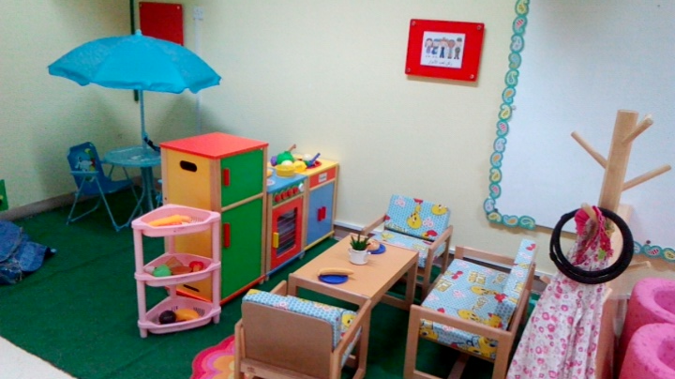 | It teaches the students to be more social and it opens up their imagination.
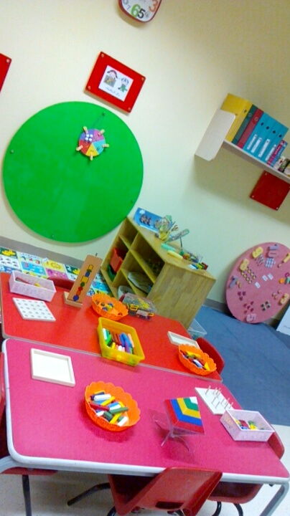  2.Mathematics Corner | Mathematics corner Strengthens the brain and helps the students to memorize numbers colors or even shapes.
3.Creativity and writing corner  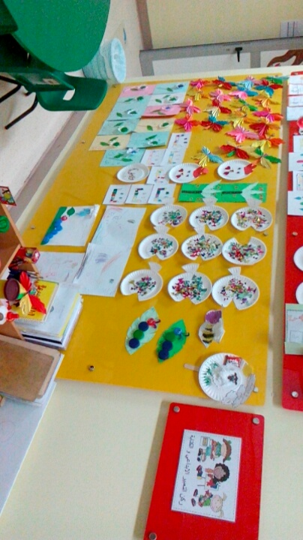 | This corner enhances the creative side of the students, and it’s a Mixture of Art and Writing where you can play and be artistic but in the same time learn how to write.
4.Building courner  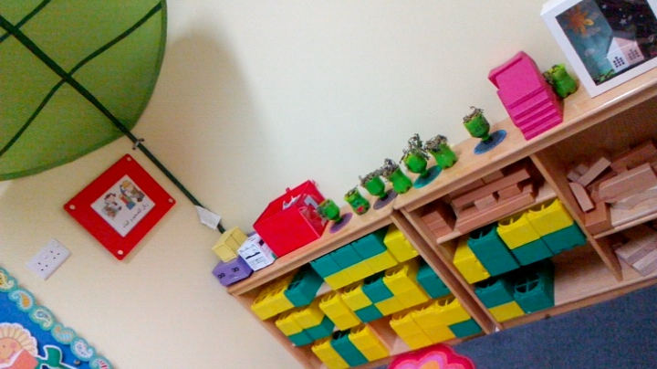 | It shows them that with small blocks you can build a tower witch opens up their imagination and make them feel proud of acomplishment.

- Were the materials, resources and equipment well prepared by the teacher? Why do you think so?

- Yes, because when she arrives at the classroom, she knows exactly where everything is, and she doesn’t waist time trying to find materials.

- Did the topic of the lesson, learning activities, together with the structure of the lesson appear to maintain students’ interest and motivation? How do you know this?

- Yes, she does combine them, for example, she gives each student cards of numbers and tells them to find the number 2, This activity excites the students, and at the same time, they learn without feeling bored.

- Is there anything you observed that you would/would not do in your planning and preparation as a teacher?
- I would involve a learning activity as much as I can in my lesson plan because I realized when the students work in activities they learn faster and they enjoy it.

Map of the class Room :

