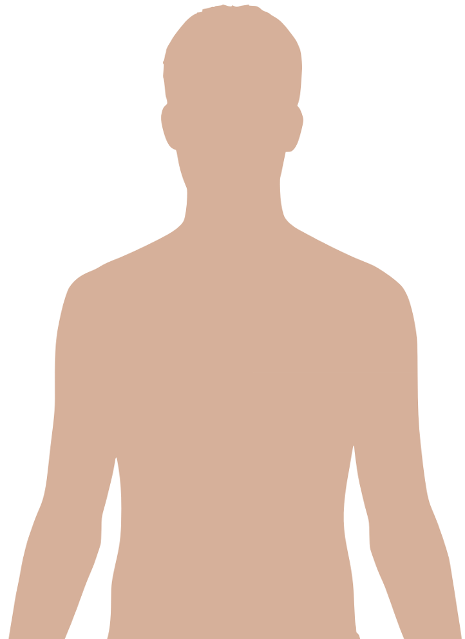Answer Sheet

3.... **Lungs**….

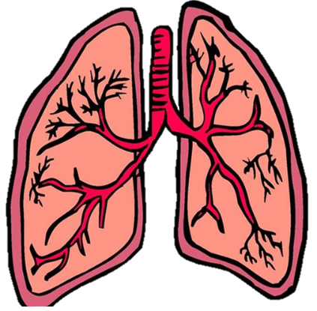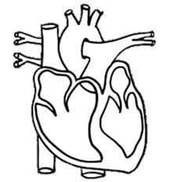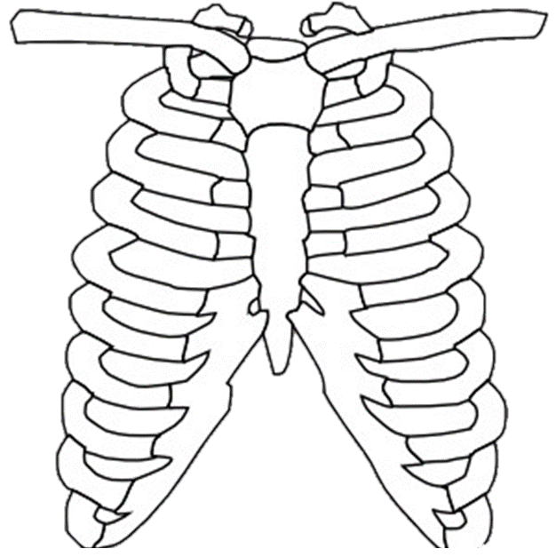

1…. **Heart**….

**Listen and Write**

**Listen and complete the text and the labels on the picture.**

**The most important muscle in your body is the­____ Heart ____ (1).**

**It moves blood around your____ Body ____ (2).**

**Your lungs are also very important. When you breath in, they fill with air, like a balloon.**

**You need to exercise and eat healthy food to keep you heart and**

**___ lungs ___ (3). Healthy.**

**When you exercise, your heart beats faster. Sport helps your heart and lungs stay ____ strong ____ (4).**