1.Saturday | 2…Sunday…. | 3.Monday | 4…Tuesday… | 5.Wednesday | 6.Thursday… | 7.Friday
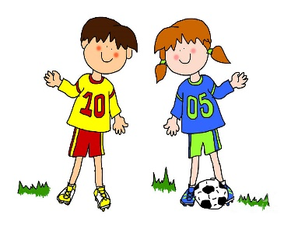 |  | 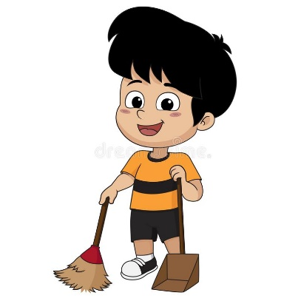
Playing football | ..Playing tennis... | ……Sweeping the floor……… | Haya is Tidying her room | …………Doing karate…………… | Haya and Khalid are Reading a book | ………Visiting Grandma………

Answer Key

